# Return to frontpage16/October/2014

# Worrisome Trends in Agriculture

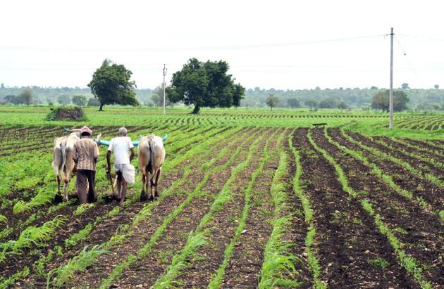

The Hindu The latest Economic Appraisal of the government has shown that Tamil Nadu needs out-of-the-box policies to tackle agriculture production and its impact on food inflation. File Photo

**Low output and land fragmentation are critical issues, says survey**

The writing on the wall for Tamil Nadu in agriculture is pretty clear, though the State’s grain production during 2013-14 was good.

The latest Economic Appraisal of the government has shown that Tamil Nadu needs out-of-the-box policies to tackle agriculture production and its impact on food inflation.

The State did well in 2013-14 to bounce back from a nightmare drought in the preceding year. Data show that between 2011 and 2013, the total production dropped by 45 per cent, from 101.52 lakh tonnes to 56.05 lakh tonnes. Paddy, the principal crop, declined by 46 per cent.

In 2013-14, estimates put the total production at 110.65 lakh tonnes, a figure similar to the pre-drought year. However, it is the data underlying the fundamentals of agriculture that require a closer reading.

According to the appraisal, while both area under cultivation and yield per hectare increased during the 10th Five Year Plan period (2002-2007), the figures dropped by 5.76 per cent and 2.65 per cent in the 11th Plan period (2007-2012), with food crops production, consisting primarily of paddy, millets and pulses, declining by 3.08 per cent.

Officials of the Agriculture Department say that since the 1970s, the area under cultivation had gone down from 70 lakh hectares to 45 lakh hectares, what with rapid urbanisation.

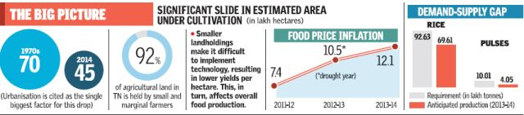

Significantly, going along with the drop in cultivated land is the yield gap. For example, the appraisal says in terms of paddy, the potential yield fixed after on-farm trials was 6 tonnes a hectare in the current scenario.

In 2011-2012, which was a favourable year in terms of rain and irrigation, the average yield was only 3.9 tonnes a hectare. In other words, the gap between potential yield and actual yield was about 2.08 tonnes a hectare.

While production alone was not the deciding factor for food inflation, it is nevertheless a contributing factor. Between 2011 and 2014, the food price inflation in the State increased from 7.4 per cent to 12.1 per cent. It is during this period that the State faced a severe drought.

Experts feel that in a situation where there is little scope for expansion of area under cultivation, usage of technology becomes vital for production maximisation. "The only answer is increasing (per hectare) productivity. This is why increasing fragmentation in agricultural landholding is a problem,” says C. Rangarajan, former Economic Advisor to the Prime Minister.

Mr. Rangarajan’s comment is significant, given the nature of agriculture land holdings in the State.

Officials estimate that 92 per cent of all farmers (nine in ten) in Tamil Nadu are small and marginal farmers. In other words, lack of scale is hindering the implementation of technology, showing in the poor yield results.

A senior official points out that the State is indeed aware of these issues and has begun experimenting with cooperative farming. There is also focus on expanding System of Rice Intensification, which has given significant results in improving the yield.

But experts feel a lot needs to be done to tackle a potential saturation given the present indicators. "Our productivity is very low by global standards. There is a lot of scope to increase yield. But the required government structures to accomplish this are either non-existent or not functional," says K. Sivasubramaniyan of the Madras Institute of Development Studies.